Questionnaire report

**Motivation**

The software we plan to design is oriented to students who want to learn sorting algorithms. However, details of learning method that students prefer remain unknown. Questionnaire is an efficient tool to collect both ideas and suggestions from target users. To gather requirements for the project, Team 10 released a questionnaire with eleven multiple choice questions and one open question. The questionnaire remained open for seven days.

**Objective**

1. Understand how well target users know about sorting algorithms and their learning habits.

2. Gather requirements from target users.

3. Ask for suggestions for the functions we plan to design.

**Time**

From November 10th to November 17th.

**Respondent**

Students from the University of Nottingham, Ningbo, China.

**Questionnaire**

Please refer to the appendix NUM.

**Result**

This survey is for collecting user requirements of animated learning software for sorting algorithms. It was released on the Wenjuanxing, an online survey platform. Overall, 207 valid questionnaires were collected. The results are as follows:

Question1. What's your gender?

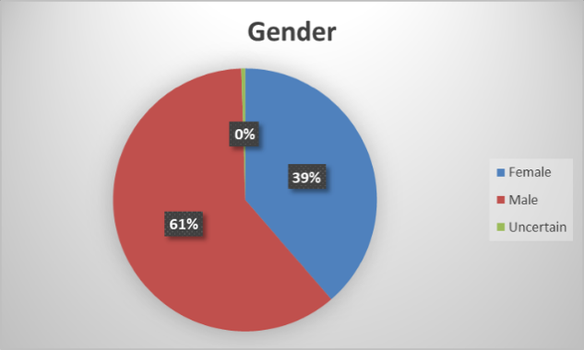

Fig1. The pie chart of results of question 1.

Overall, 207 students from the University of Nottingham, Ningbo, China were investigated, among which 61% were male, and 39% were female. The ratio of male and female is about 3:2.

Question2. Which year are you in university?

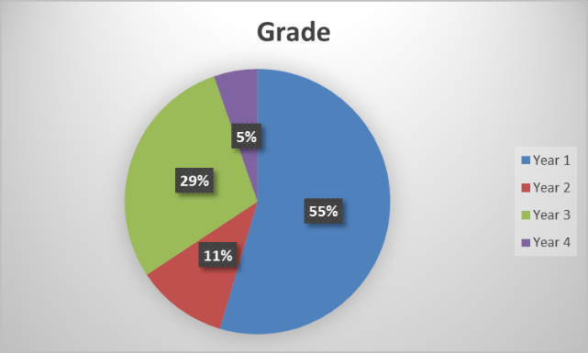

Fig2. The pie chart of results of question 2.

More than half of the participants were Year 1 students, which takes 55 percent. The second is from Year 3 and Year 2, accounting for 29% and 11% respectively. 5% of those who filled in the questionnaire were Year 4 students.

Question3. I learn algorithms because of:

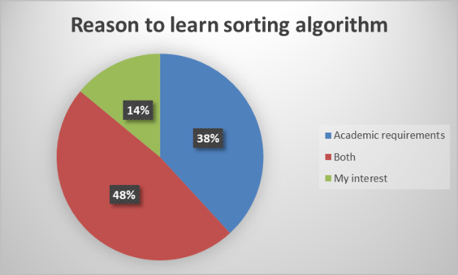

Fig3. The pie chart of results of question 3.

For the learning motivation, the proportions of ‘both’ and ‘preparing for examination’ are both high. By contrast, students who learn sorting algorithms because of interest are relatively small.

Question4. How well do you know about sorting algorithms? (The content of following questionnaire will be adjusted according to your answer)

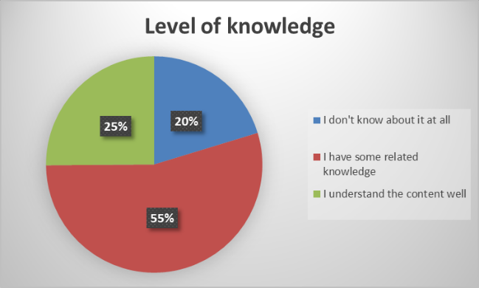

Fig4. The pie chart of results of question 4.

According to the investigation result, most of the participants have some knowledge of sorting algorithms. However, 20% of participants choose that they do not know what is sorting algorithms at all. This shows that providing a module for teaching basic concepts of algorithms for beginners might be necessary.

Question5. In your opinion, a software which helps learn algorithms should more focus on:

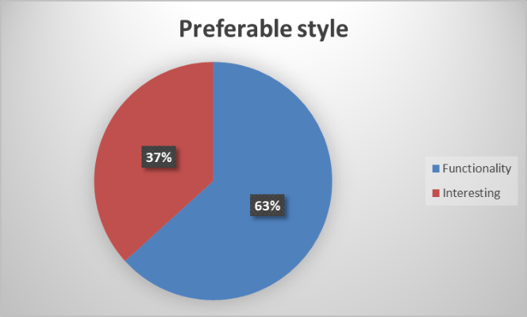

Fig5. The pie chart of results of question 5.

According to the investigation result, 63% preferred useful learning functions rather than entertaining interactive functions. This means Team 10 may reduce some of the interactive game design and pay more attention to the functions, which could provide more help for learning and understanding the algorithms.

Question6. How much time are you willing to spend each time using our software?

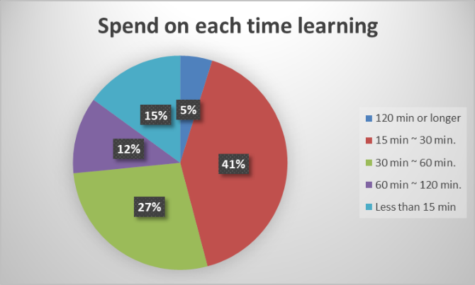

Fig6. The pie chart of results of question 6.

In general, the participants thought that within 60 minutes was acceptable for them to learn each time. More than half of the participants chose to spend 15-30 minutes each time. This shows that it is better to control one single algorithm’s learning time of within about 30 minutes.

Question7. You learn algorithms or programming mainly by:

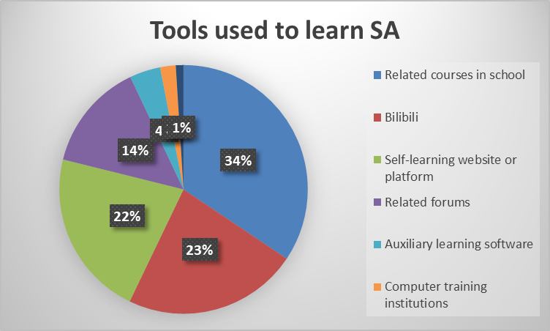

Fig7. The pie chart of results of question 7.

In addition to the university's courses, there are a large number of students learning sorting algorithms on website platforms. Video teaching software is top-rated, which was chosen by 34% of students. Other participants preferred to discuss with others in forums. It suggests that the market for our products is vast. Moreover, Team 10 may provide a function that allows users to share their thoughts with others.

Question8. Which platform do you prefer to use this software (e.g. likes to use mobile terminal most, and computer terminal second, then1 iOS/Android, 2 PC/Mac...)

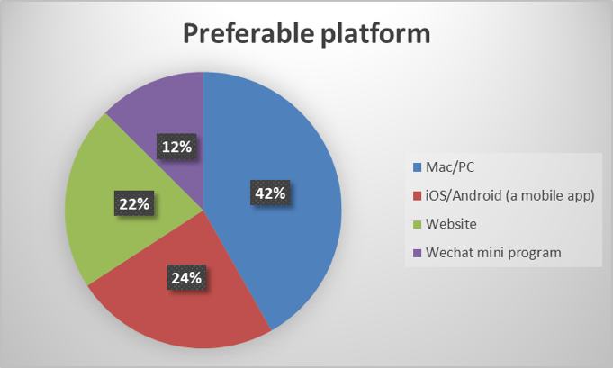

Fig8. The pie chart of results of question 8.

The investigation result demonstrates that most participants are used to use similar learning software on computers. Secondly popular ones are mobile apps and websites. This result may help decide the development platform.

Question9. What goal you want to achieve through learning:

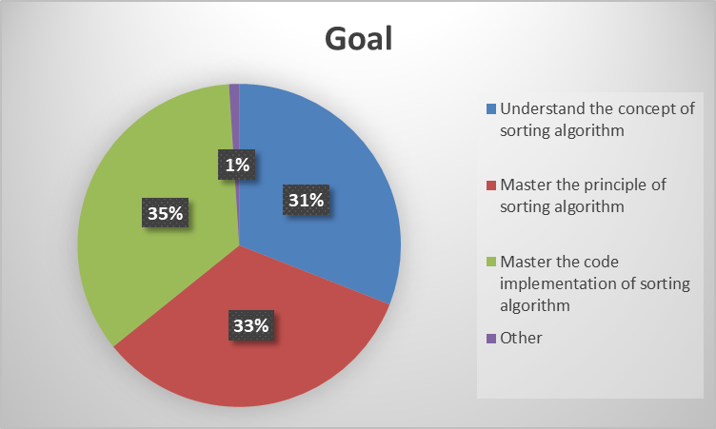

Fig9. The pie chart of results of question 9.

For these three levels of learning output provided, the choices of participants were approximately equal. That means we may need to provide a hierarchical teaching method so that users of different levels can all gain some knowledge they require.

Question10. What language would you like to present the code?

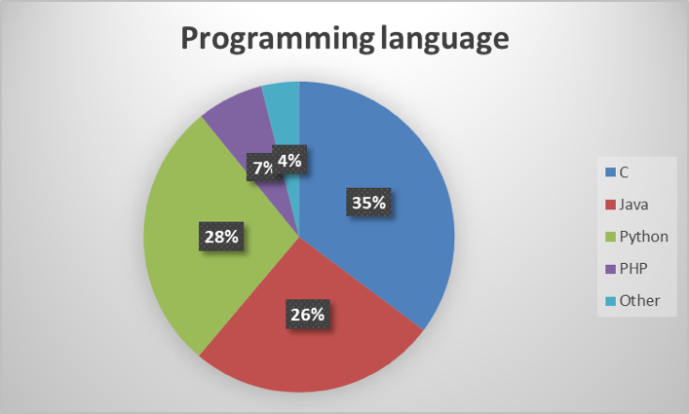

Fig10. The pie chart of results of question 10.

This question aims to collect the programming language preference of our target users. The result shows that users’ demand for C, Java, and Python is relatively high.

Question11. Which following function do you prefer?

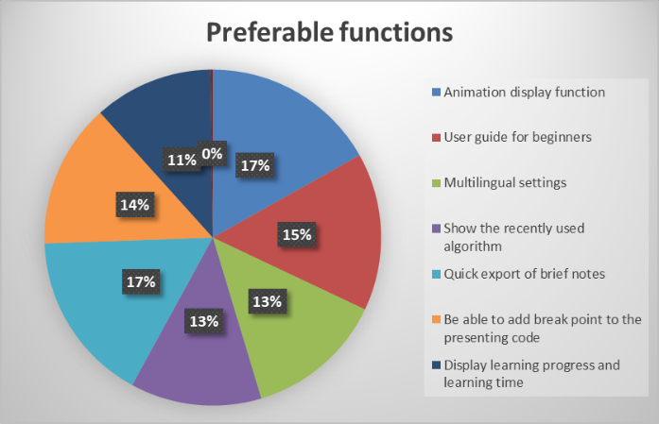

Fig11. The bar chart of results of question 11.

For the envisioned functions, what the participants like best are the animation display function and exporting brief notes function. The second is the user guide and adding breakpoints. Lots of participants select multilingual settings function and recently used function, both are approximately 13%. The learning progress and learning time displaying function are also popular. The result demonstrates that our envisioned functions can be acceptable to the users basically. Further, one participant proposed that some practice questions after learning would be helpful.

Question12. What other functions do you think the software should have? Are there anything we should pay attention to?

This is an open question, and the participants can choose to answer it or not. Some valuable answers are as follows:

1. Maybe provide contact information of the developers and provide access to view the source code.
2. Share functions! If it is a good piece of software, I want to be able to share it with others.
3. The interface must be clean and delightful.
4. It should be easy to use.
5. Maybe provide a forum, and users can discuss multiple implementations on it.
6. Enable users to implement their own code.

**Analysis and suggestion**

The participants in this survey are students fromthe University of Nottingham, Ningbo, China. Among them, 55% are from year 1, 11% are from year 2, 29% are from year 3, and 5% are year 4 students. The proportion of males and females is relatively equal. They learn sorting algorithms for interest or examination requirements. About 75% of the participants have varying degrees of understanding of sorting algorithms, while some know nothing about sorting algorithms.

To summarize the survey result, some important points drawn from this questionnaire are as follows:

1. It is suggested to provide a basic conceptual introduction and basic learning thought guidance for users who do not have any knowledge of algorithms.
2. Compared with the entertainment functions, participants preferred practical ones. It is suggested to reduce game mechanics and focus on developing functions that are more helpful for learning algorithms.
3. Some participants proposed that providing a function, which can share and discuss their thoughts with others, like forum, may help learning.
4. To ensure users with different levels of algorithmic bases can all gain knowledge from this software, it is suggested to provide hierarchical teaching functions.
5. For those who have examination requirements, offering more practice questions will attract them to use this software.
6. Many participants mentioned that they preferred clean and delightful interfaces. Therefore, GUI design is one thing that needs to consider.

**Appendix**

**User demand questionnaire on the development of animation teaching software for sorting algorithm**

Our project aims to design a software which can help users who either have no experience in coding or know a little about sorting algorithms and their correctness. The basic feature of this software is clearly showing the swapping animation of sorting elements step by step. Users can also interact with the software to control the sorting process. Additionally, there different kinds of sorting algorithms provided, such as bubble sort, quick sort, merge sort, etc. As for more advanced modules we designed, we plan to focus on the correctness of sorting algorithms, demonstrating why a specific sorting algorithm is correct. Moreover, we plan to add some additional functions, which needs your help!

All information in this questionnaire is used for research and project development, and will not be disclosed, transmitted or used for other purposes. The filling time of the questionnaire would be no more than 2 minutes. Please answer those questions according to your actual ideas. Thank you!

(1) **What is your gender?**

* Female
* Male
* Uncertain

(2) **What year are you in?**

* Year 1
* Year 2
* Year 3
* Year 4

(3) **I learn algorithms because of:**

* My interest (not examination-oriented)
* Academic requirements (examination-oriented)
* Both

(4) **How well do you know about sorting algorithms?** (The content of following questionnaire will be adjusted according to your answer)

* I don’t know about it at all.
* I have some relevant knowledge.
* I understand the content well.

(5) **In your opinion, a software which helps learn algorithms should more focus on:**

* Interestingness (have some characters of game, which is entertaining, with lively and attractive interface)
* Functionality (concise interface, with learning function only)

(6) **How much time are you willing to spend in learning with our software?**

* Less than 15 min
* 15 min ~ 30 min
* 30 min ~ 60 min
* 60 min ~ 120 min
* 120 min or longer

(7) **You learn algorithms or programming mainly through:** (multiple-choice)

* Related courses in school
* Self-learning website or platform (e.g. rookie course, MOOC, Tencent class)
* Bilibili
* Computer training institutions
* Related forums (e.g. CSDN, Baidu Post Bar, etc.)
* Auxiliary learning software

Other:

(8) **Which platform do you prefer to use this software?** (Please sort the items, e.g. like to use mobile terminal most, and computer terminal second, then: 1 mobile, 2 computer...)

* PC/Mac (need to download and install)
* IOS/Android (a mobile app)
* WeChat miniApp
* Website

(9) **What goal you want to achieve through learning?**(multiple-choice)

* Understand the concept of sorting algorithms.
* Master the principle of sorting algorithms.
* Master the code implementation of sorting algorithms.

Other:

(10) **What language would you like to present the code?** (multiple-choice)

* C
* Java
* Python
* PHP

Other:

(11) **Which following function do you prefer?** (multiple-choice)

* Display animation (speed control, go to previous step or next step, pause button).
* A user guide for beginners.
* Multilingual settings.
* Show the recently used or learned algorithm
* Quick export of brief notes
* Be able to add break point to the presenting code
* None of above:

(12) (optional) **What other functions you think the software should have?** You are welcome to talk about your expectations of our software.